WEB TECH-BY ANIRUDH KASHYAB.LM
EXP.NO: 8
DATE: 04/03/2026

activity_main.xml
<?xml version="1.0" encoding="utf-8"?>
<androidx.constraintlayout.widget.ConstraintLayout
xmlns:android="http://schemas.android.com/apk/res/android"
android:layout_width="match_parent"
android:layout_height="match_parent">
<TextView
android:id="@+id/sampleText"
android:layout_width="wrap_content"
android:layout_height="wrap_content"
android:text="Hello World"
android:textSize="24sp"/>
<Button
android:id="@+id/changeStyleButton"
android:layout_width="wrap_content"
android:layout_height="wrap_content"
android:text="Change Style"/>
</androidx.constraintlayout.widget.ConstraintLayout>

MainActivity.java
package com.example.font_change;
import android.graphics.*;
import android.os.Bundle;
import android.widget.*;
import androidx.appcompat.app.AppCompatActivity;
public class MainActivity extends AppCompatActivity {
TextView text;
Button btn;
boolean changed=false;
protected void onCreate(Bundle b){
super.onCreate(b);
setContentView(R.layout.activity_main);
text=findViewById(R.id.sampleText);
btn=findViewById(R.id.changeStyleButton);
btn.setOnClickListener(v->{
if(!changed){
text.setTextColor(Color.RED);
text.setTypeface(Typeface.DEFAULT_BOLD);
Toast.makeText(this,"Changed!",Toast.LENGTH_SHORT).show();
}else{
text.setTextColor(Color.BLACK);
text.setTypeface(Typeface.DEFAULT);
Toast.makeText(this,"Reset!",Toast.LENGTH_SHORT).show();
}
changed=!changed;
});
}
}

OUTPUT:
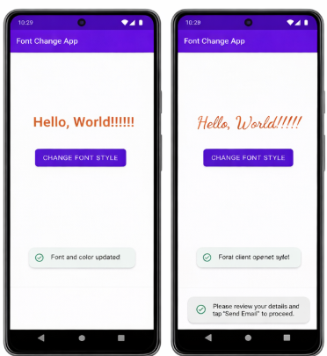

RESULT:
Android app executed successfully.

